**Gender Pay Gap Statement (for website)**

Here at Fresenius Kabi, we pride ourselves in our stance on equality – we treat all employees equally and value their contribution not their gender, and we believe our gender pay gap data reflects this. By focussing on rewarding our employees for their contribution, we drive a natural balance across our policies and processes.

**Gender Pay Gap**

|  |  |  |  |  |  |  |  |  |
| --- | --- | --- | --- | --- | --- | --- | --- | --- |
| **Difference between men and women** | **MEAN**  **Average** | | | | **MEDIAN**  **Middle** | | | |
| **2017** | **2018** | **2019** | **2020** | **2017** | **2018** | **2019** | **2020** |
| Gender Pay Gap | 7.5% | 4.4% | 5.9% | 3.6% | -4.9% | -7.4% | -4.0% | -4.1% |

Our gender pay gap is still showing that we have a negative gender pay gap at median, however our goal is to achieve a zero difference between males and females. At both mean and median we continue to be significantly lower than the current national average of 6.5% (mean) and 15.9% (median).

**Gender Bonus Gap**

|  |  |  |  |  |  |  |  |  |
| --- | --- | --- | --- | --- | --- | --- | --- | --- |
| **Difference between men and women** | **MEAN**  **Average** | | | | **MEDIAN**  **Middle** | | | |
| **2017** | **2018** | **2019** | **2020** | **2017** | **2018** | **2019** | **2020** |
| Gender Bonus Gap | 26.7% | 19.6% | 19.2% | 15% | 8.3% | 18% | 19.3% | 15.3% |

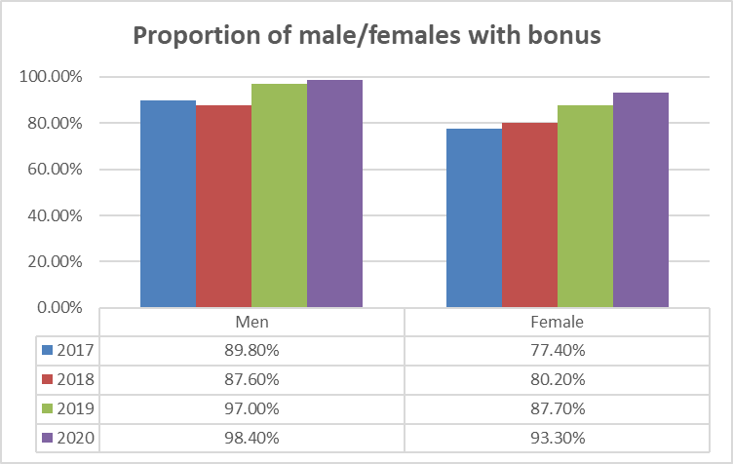

The gender gap in our bonus pay reflects a small number of male senior leaders eligible for bonuses versus female senior leaders in 2020. As can be seen from the numbers, that gap is closing as we continue to address the balance. We have since reshaped commercial and senior teams which will be prevalent in the numbers for 2021.

**Pay Quartiles**

|  |  |  |  |  |
| --- | --- | --- | --- | --- |
| **Number of females per pay quartile** | **Women** | | | |
| **2017** | **2018** | **2019** | **2020** |
| Top Quartile | 54.9% | 52.3% | 53.2% | 56.1% |
| Upper Middle Quartile | 77.7% | 79.5% | 77.3% | 74.2% |
| Middle Quartile | 65% | 59.5% | 63.4% | 59.4% |
| Lower Quartile | 54.4% | 50.9% | 56.0% | 57.5% |

**How we are continuing to tackle our gender pay gap and the progress made**

Our fundamental principles from previous years remain unchanged as we believe that as we continue to critically review our structures with balance in mind, we will achieve our goal of zero difference. We know that if we stick to being fair and equitable with all our employees, we will continue to do the right thing with our gender pay gap. Continued equal access to our Leadership and Sales Academy will create the foundations for greater gender balanced management and leadership structures.