Introduction

At Fresenius Kabi, we pride ourselves on treating all our employees fairly. We understand that equality, diversity and inclusivity are essential in attracting and retaining talent and aim to create a culture that enables the highest-level service to our employees, customers and patients.

2021 Gender Pay Gap results illustrate that the average gender pay gap in Fresenius Kabi has dropped for the third year in a row and now stands at 1.1%, significantly below the UK average of 7.9%. Whilst this demonstrates a continuous positive trend in equality at Fresenius Kabi, we intend to continue activities to further improve.

Gender Pay Gap

We have a negative gender pay gap at median, this is explained through a salary bench marking exercise that was undertaken, resulting in salary increases within one of our teams, which comprises mainly of female employees. As part of our ongoing equality, diversity and inclusivity initiatives, we aim to seek ways to attract more male candidates to these roles, as well as explore how to entice more female applicants into roles which have traditionally comprised of mainly male employees.

Gender bonus gap

Our gender pay gap for bonus payments has closed slightly in terms of average and middle, compared to previous years.

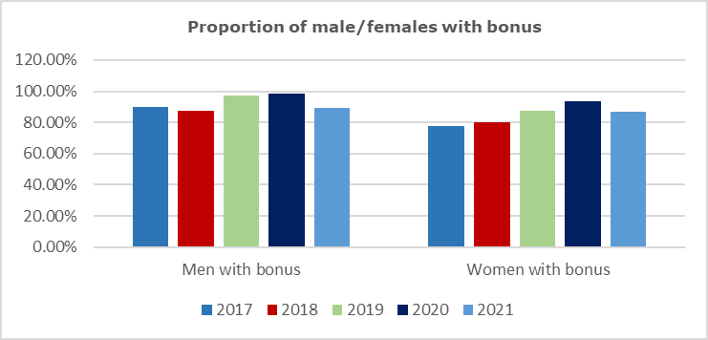

There is a difference of 2.8% between genders when comparing 2021 to 2020, we continue to focus on opportunities to further reduce this gap.

Pay Quartiles

Compared to 2020, there has been increases in female employees in both the top and middle top quartiles. Some of this difference is explained by the same salary benchmarking exercise outlined above, which moved females into higher quartile rankings.

How we will continue to tackle our gender pay gap

Fundamentally our end goal remains unchanged; at Fresenius Kabi we aim to reach a point where our gender pay gap is zero across all metrics. Our Equality, Diversity and Inclusivity strategy continues to evolve, and this will present opportunities to create more balance between all employees.

